# How to run:

1. Open command prompt at the selected directory

The easiest way is when you are at the selected directory, type “cmd” in Search Box and hit Enter

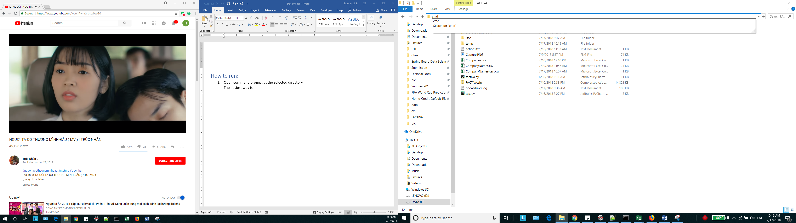

1. Type “python factiva.py” to start the program
2. It will open the Firefox Browser and start to scrap data. You need to login once. If you see

“Connection refused … “ then just hit refresh

1. The program will read these following file

* “config.json”: define a download directory (should be the same folder) and list of company names.
* “actions.json”: series of actions, 1 means “include” and 0 mean “exclude”
* “companyName.csv”: list of company names